Part 1:
Task 1.1:
TCP Server:
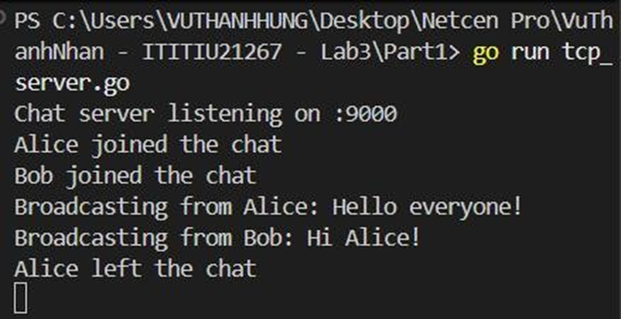

TCP Client 1 (Alice):
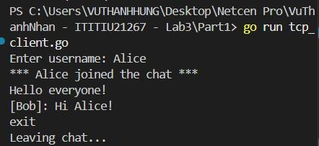

TCP Client 1 (Bob):
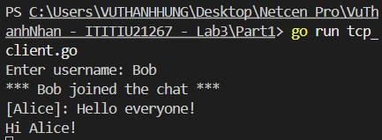
Task 1.2:
TCP Server:
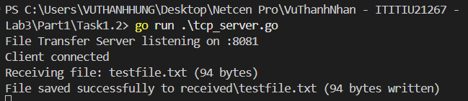

TCP Client:
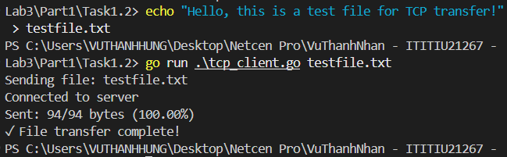

Receive file data and save it to ./received/:
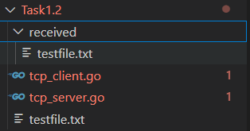

Part 2:
Task 2.1:
UDP Ping Server:
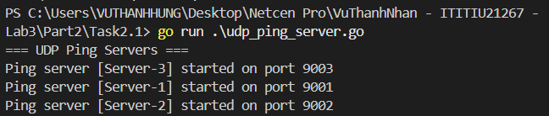

UDP Ping Client:
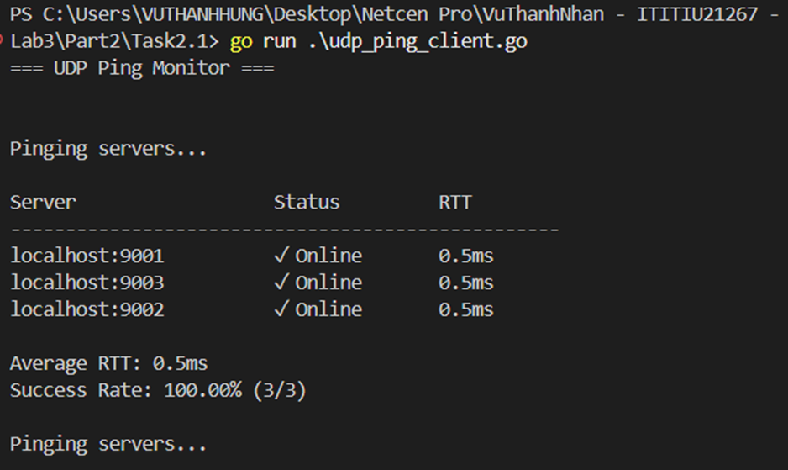

Task 2.2:
UDP Discovery Server:
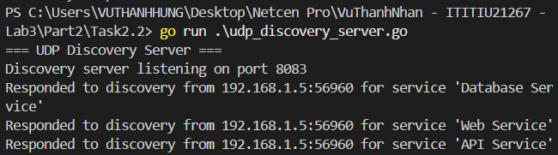

UDP Service Discovery Client:
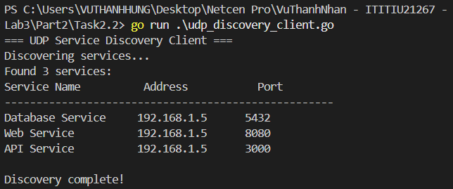

Part 4:
Server:
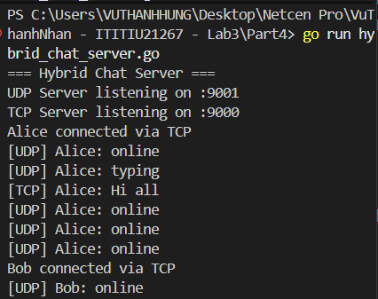

Client Alice:
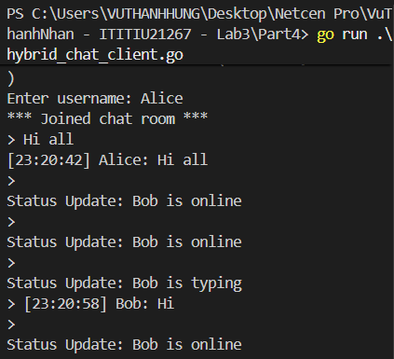

Client Bob:
